RETAIL SALES, ITEM & OUTLET PERFORMANCE ANALYSIS
Count of Stores by Outlet Type:
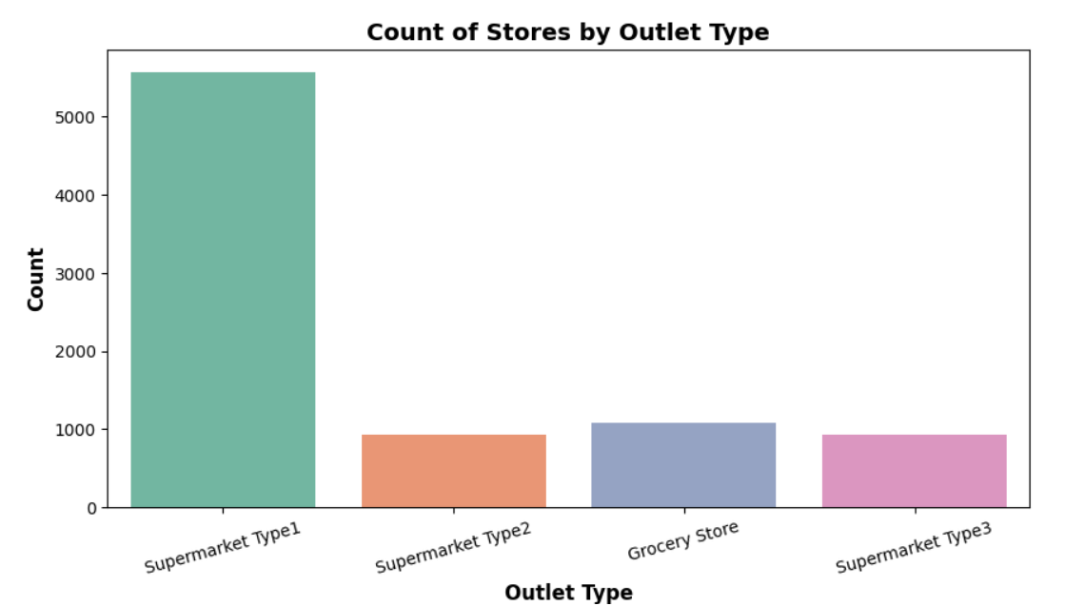
From the Count plot we can see that supermarket Type 1 has majority of stores where as supermarket type2 and 3 marks smaller store counts
Therefore, the business is majorly depends on supermarket type 1 so it is necessary to ensure this store remain consistent supply of goods.
Count plot for product categories ranked by frequency

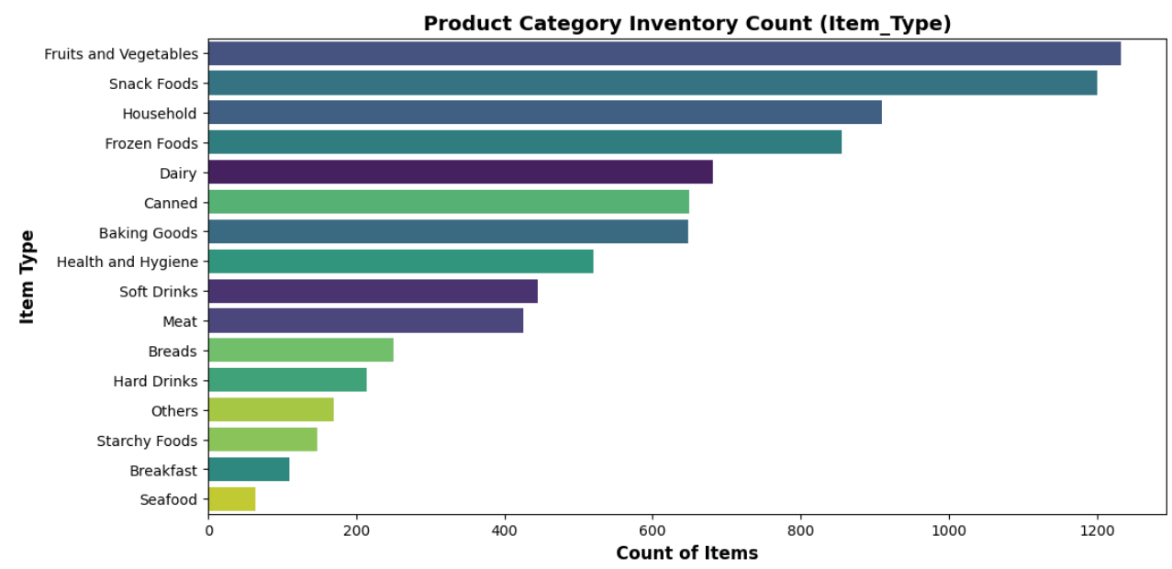
From the above plot we can understand that Fruits and Vegetables and Snack Foods are the top product categories in inventory, whereas Seafood have the lowest representation.
so it is important to maintain fresh supply of fresh food categories to prevent spoilage losses.
Plot distribution of Item_MRP
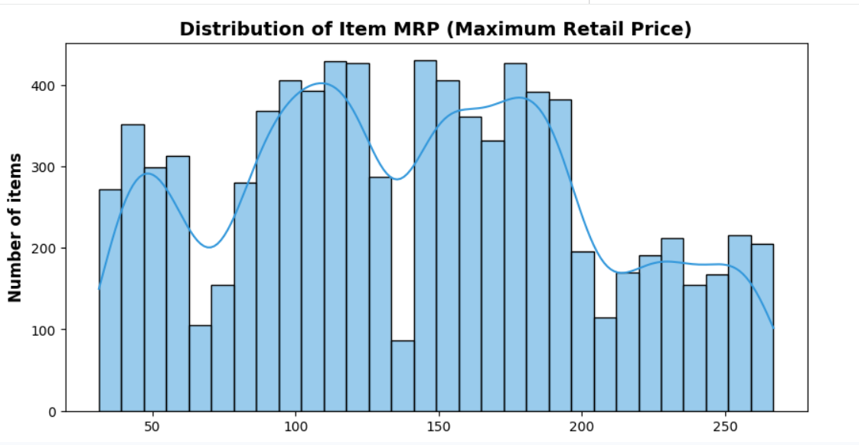
Four Price Groups: Items in the store naturally group into four price levels:
Cheap Items: $30-$90
Mid-Price Items: $90-$140
Upper Mid-Price Items: $140-$200
Expensive Items: $200-$270
so it is important to Pair a low-cost item with an expensive item or we can place medium prized item near lower price so that customer at times comparing the less difference they tend to buy medium prized items.
Scatter plot showing relationship between MRP and Sales: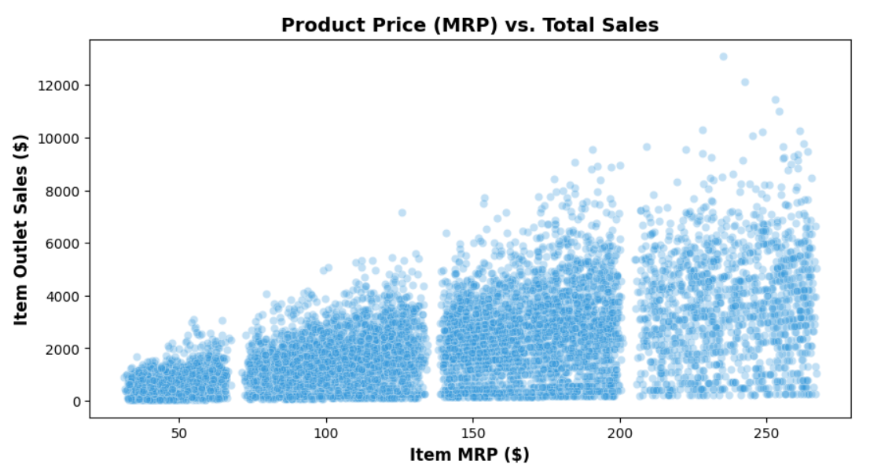
From the scattered plot we can see that when the MRP increases Total sales revenue are also increased.
Higher-priced items are the primary driver of store revenue.
So it is necessary to stock on higher-priced product to raise overall store income.
Bar plot comparing average sales by store type
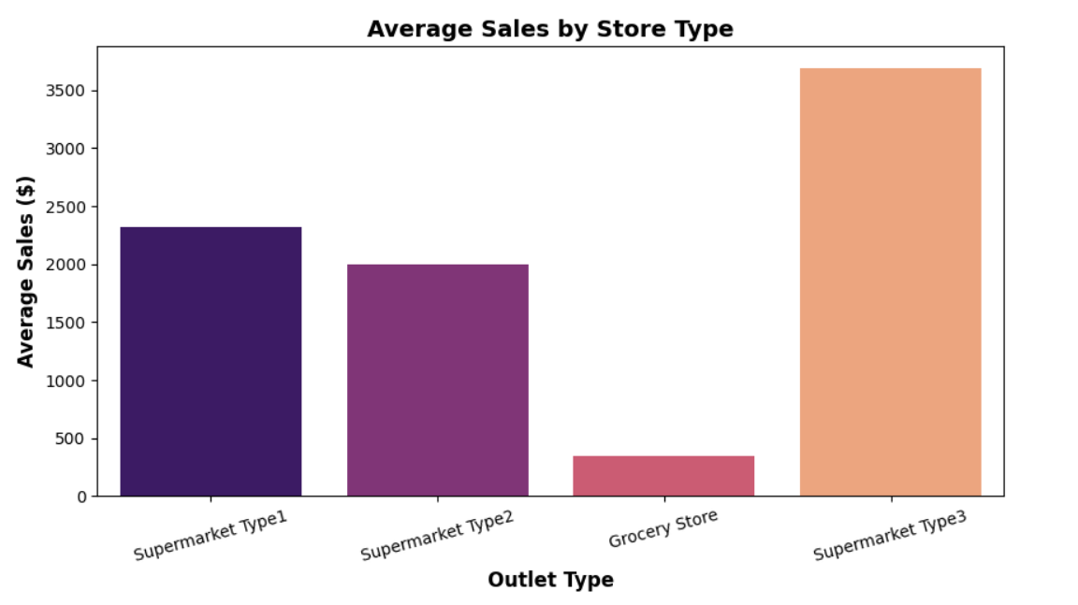
Supermarket Type 3 makes significantly higher average sales compared to all other formats, while Grocery Stores make the lowest sales.
So it is important to invest in building or upgrading locations into Supermarket Type 3 formats rather than small grocery outlets.
Sales Distribution Across Outlet Types:
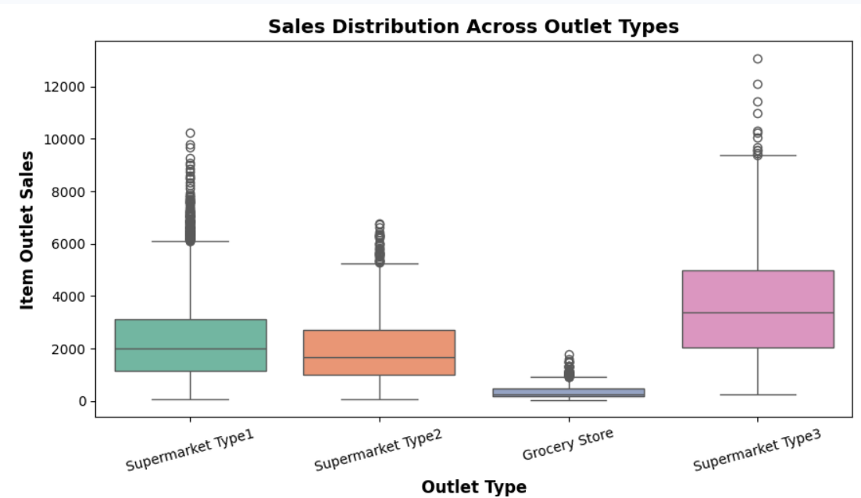
Supermarket Type 3 consistently achieves the highest median sales and maximum sales volume compared to all other store formats Which implies Larger supermarket with more inventory space has higher sales value
Therefore inventory expansion will increase the sales revenue
And Grocery Stores, should focus on high-turnover essential items to maximize limited floor space efficiency.
Bar Plot to identify which product categories gives highest revenue across stores:
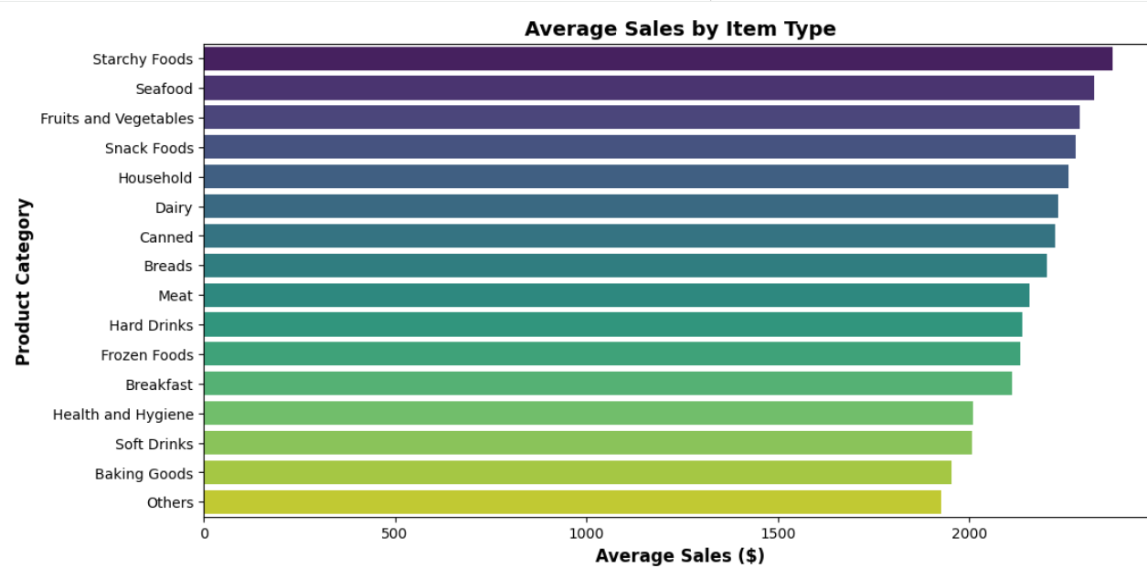
From the bar graph we can say that starchy Foods, seafood, Fruits and vegetables and snacks produce higher sales revenue where as others and baking goods generates lower sales value
So, it is necessary to restock the higher sales revenue product to prevent out of stocks
Average sales by Location Tier and Outlet Size:
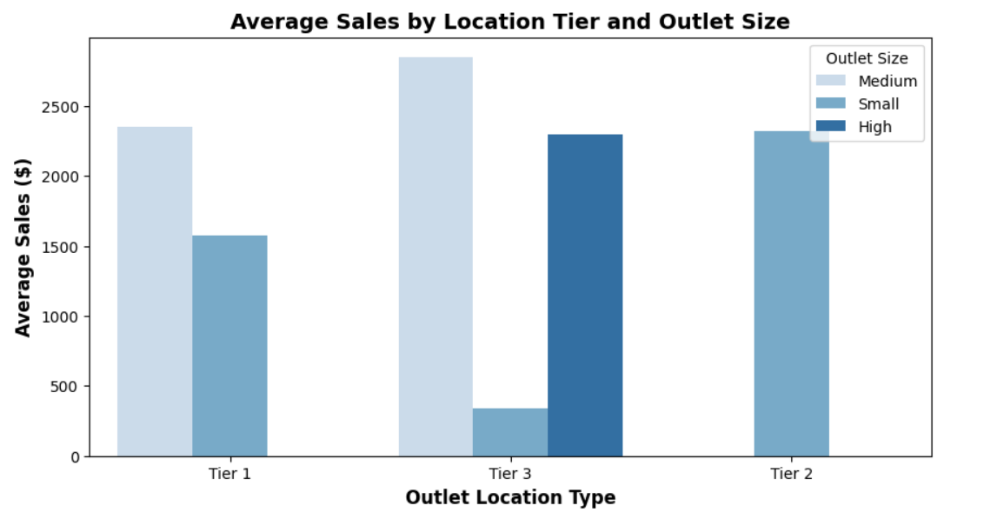
In the graph we can see that Tier 3 Cities (Small Towns) make the most money when stores are Medium-sized even the Tier 2 Cities (Mid-sized Cities) also has good performance in sales , even though they only have Small stores where as Tier 1 Cities (Big Metro Cities)aren't the top earners, with Medium stores making around
So from this we can suggest that instead of investing in metro cities they can invest by building medium sized stores in tier 2 and tier 3 .
Correlation Heat map of numerical feature:
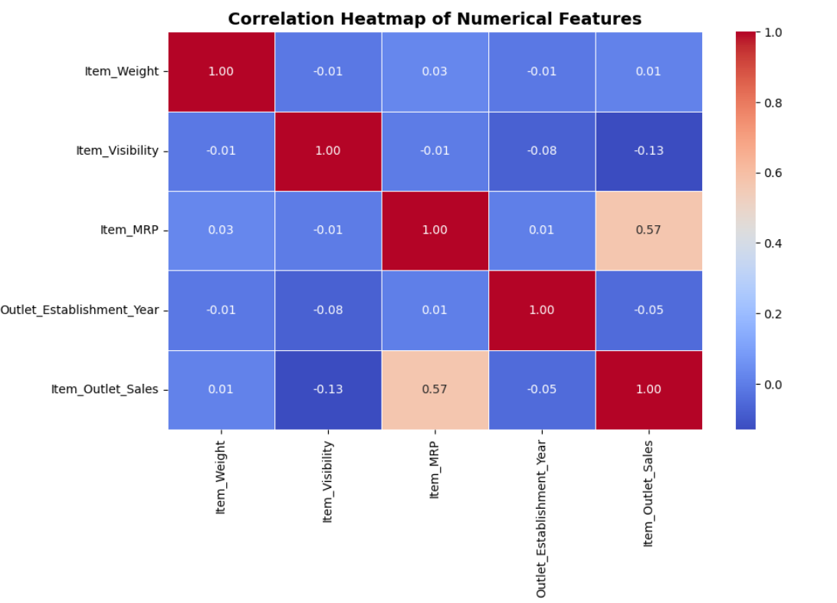
From this correlation heatmap, is that Item_MRP has the strongest positive correlation with total sales at 0.57, making it the key driver of sales revenue in our dataset.
Similarly other features like Item_Weight and Outlet_Establishment_Year show values close to 0, indicating virtually no linear relationship with sales.
Item_Visibility shows a slight negative correlation (-0.13), suggesting that display area alone does not guarantee higher sales.

DASHBOARD:
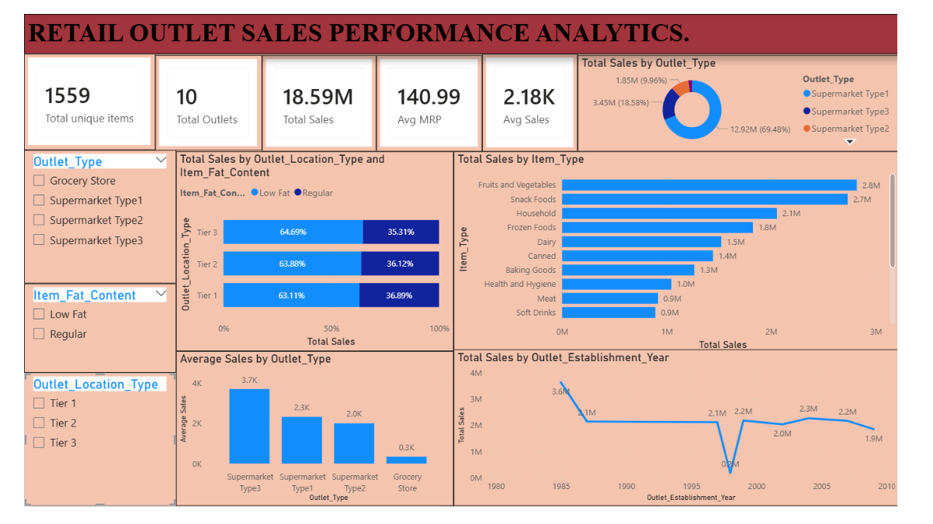
Insights:
1. Descriptive Analysis:
Total Revenue: Your stores generated 18.59M Crore in total sales across 10 outlets and 1,559 products.
Top Best-Sellers: Fruits & Vegetables (2.8 M) and Snack Foods (2.7 M) brought in the highest sales.
Customer Choice: Low Fat products made up 64% of total sales compared to Regular products 36%.
2. Diagnostic Analysis:
Store Format: Supermarket Type 3 made the most money per order because bigger supermarkets offer more variety and higher-priced items.
Store Size: Medium-sized stores performed better than large (High-sized) stores, showing that bigger space doesn't always mean higher sales.
Small Stores Struggled: Small Grocery Stores had very low sales because they carry fewer products and have limited space.
3. Predictive Analysis:
Healthy Product Demand: Sales for Low Fat items will continue to grow as customers focus more on health.
Medium Store Success: Opening Medium-sized supermarkets will consistently bring in higher sales than opening small grocery shops.
Popular Items: High demand for Fruits, Vegetables, and Snack Foods will remain steady throughout the year.
4. Prescriptive Analysis:
Stock Top Products: Keep high inventory for Fruits & Vegetables and Snack Foods so you never run out of stock.
Focus on Medium Supermarkets: Expand by opening more Medium-sized Supermarkets instead of small grocery stores.
Promote Low Fat Items: Give better shelf display to Low Fat items to boost revenue further.
Fix Small Stores: Add special discounts or popular everyday items to small grocery stores to increase their sales.
Conclusion:
The dashboard shows that product price (Item MRP) and store type (Outlet Type) have the biggest effect on overall sales.
Placing items where customers can easily see them clearly helps boost total sales in every store.
Bring in customer ratings and reviews to see how product satisfaction affects overall sales.
Add inventory data to monitor stock levels and prevent items from going out of stock.
Track how special offers, seasonal sales, and store discounts impact total revenue.
Using sales predictions helps store managers pick the right items to stock instead of relying on pure guesswork.
Showing both actual past sales and expected future sales in one place gives leaders a quick, clear view of business performance.

